CSS BRITISH HISTORY · TOPIC 3 · QUESTION ANSWERS
Pitt, the French Revolution, Napoleon and the Union with Ireland (1783–1815)
Every past question on the French Revolution's influence on Britain and the Union of 1801 — answered in full, with answer maps

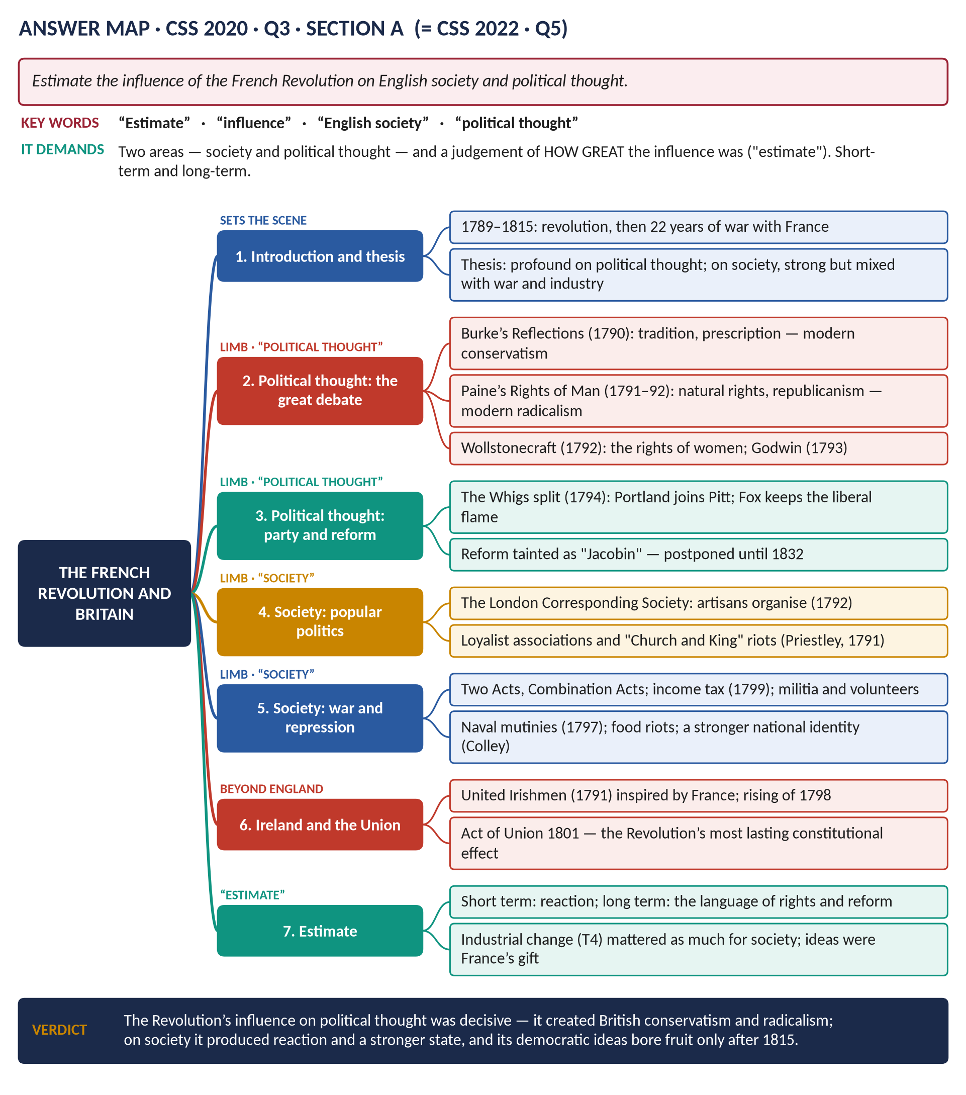
Four full answers, the identical 2022 repeat shown with its adaptation, and one short note (2016–2025); the three past MCQs solved; five predicted questions with outlines.
Topic 3 of 10 · companion to T3KB (the Knowledge Base)
Contents
HOW TO USE THIS · Updating the contents
Right-click the contents → Update Field → Update entire table, before saving as PDF.

How to Use These Answers 5
Answer 1 · Measures to Check the Influence of the French Revolution 6
The model answer 7
(1) Introduction and thesis 7
(2) The influence that alarmed the government 7
(3) Measure one: propaganda and loyalism 7
(4) Measure two: prosecutions 7
(5) Measure three: emergency laws 7
(6) Measure four: force and war 8
(7) Measure five: Ireland 8
(8) Did the measures work? 8
(9) Conclusion 9
Answer 2 · The Influence of the French Revolution on English Society and Political Thought 10
The model answer 11
(1) Introduction and thesis 11
Political thought 11
(2) Burke and conservatism 11
(3) Paine and radicalism 11
(4) The wider debate 11
(5) The effect on parties and reform 12
English society 12
(6) Popular politics and loyalism 12
(7) Repression and the state 12
(8) War, economy and identity 12
(9) Ireland 13
(10) Estimate 13
(11) Conclusion 13
Answer 3 · The Same Question, Set Again 14
How to use Answer 2 in 2022 (or 2027) 14
Answer 4 · "A Sort of Panic": The After-Effects of the French Revolution 15
The model answer 16
(1) Introduction and thesis 16
(2) From welcome to fear 16
(3) Was there a panic? 16
The after-effects 16
(4) Political 16
(5) Legal 17
(6) Social and intellectual 17
(7) Ireland 17
(8) War 17
(9) Conclusion 17
Short Note 19
Impact of the French Revolution on the British Economy and Society 19
(1) Introduction 19
(2) The economy 19
(3) Society 19
(4) Assessment 20
Answer 5 · The Act of Union 1801: Controversies, Nationalism and Stability 21
The model answer 22
(1) Introduction and thesis 22
(2) Background 22
(3) The British perspective 23
(4) The Irish perspectives 23
(5) The controversies 24
(6) The impact on Irish nationalism 24
(7) The impact on the stability of the United Kingdom 24
(8) Conclusion 24
Part Two — The Past MCQs, Solved 25
CSS 2024 · MCQ 15 25
CSS 2026 · MCQ 5 25
CSS 2026 · MCQ 15 25
Part Three — Five Predicted Questions, with Outlines 26
Predicted 1 · "How did Britain contribute to the defeat of Napoleon?" 26
Predicted 2 · "Assess the impact of the Napoleonic Wars on Britain." 26
Predicted 3 · "Evaluate Pitt the Younger as a peacetime reformer and a war minister." 26
Predicted 4 · "Compare the political ideas of Edmund Burke and Thomas Paine." 26
Predicted 5 · "What were the causes and consequences of the Irish rebellion of 1798?" 27

How to Use These Answers
# | Paper | Question (short) | Answer
1 | 2016 Q2 | Measures adopted to check the influence of the French Revolution | Answer 1
2 | 2020 Q3 | Influence of the Revolution on English society and political thought | Answer 2
3 | 2022 Q5 | Identical to 2020 Q3 — how to reuse Answer 2 | Answer 3
4 | 2023 Q3 | "A sort of panic" — the after-effects of the Revolution | Answer 4
5 | 2025 Q8(a) | Short note: impact on the British economy and society | Short note
6 | 2025 Q3 | The Act of Union 1801: controversies, nationalism, stability | Answer 5

Every answer has: the question as set · its answer map · decoding the question · a model answer with numbered headings, a figure and a verdict · why this answer scores.
TRAP — DO NOT FALL INTO IT · The same material, four angles
The four Revolution questions draw on one body of knowledge (T3KB, Chapter 2) but ask for measures (2016), influence (2020, 2022), panic and after-effects (2023) and economic and social impact (2025). Build your headings from the question's own words each time.

Answer 1 · Measures to Check the Influence of the French Revolution
THE QUESTION · CSS 2016 · Q2 · Section A · 20 marks
What measures were adopted by England to check the influence of the French Revolution of 1789 on England?

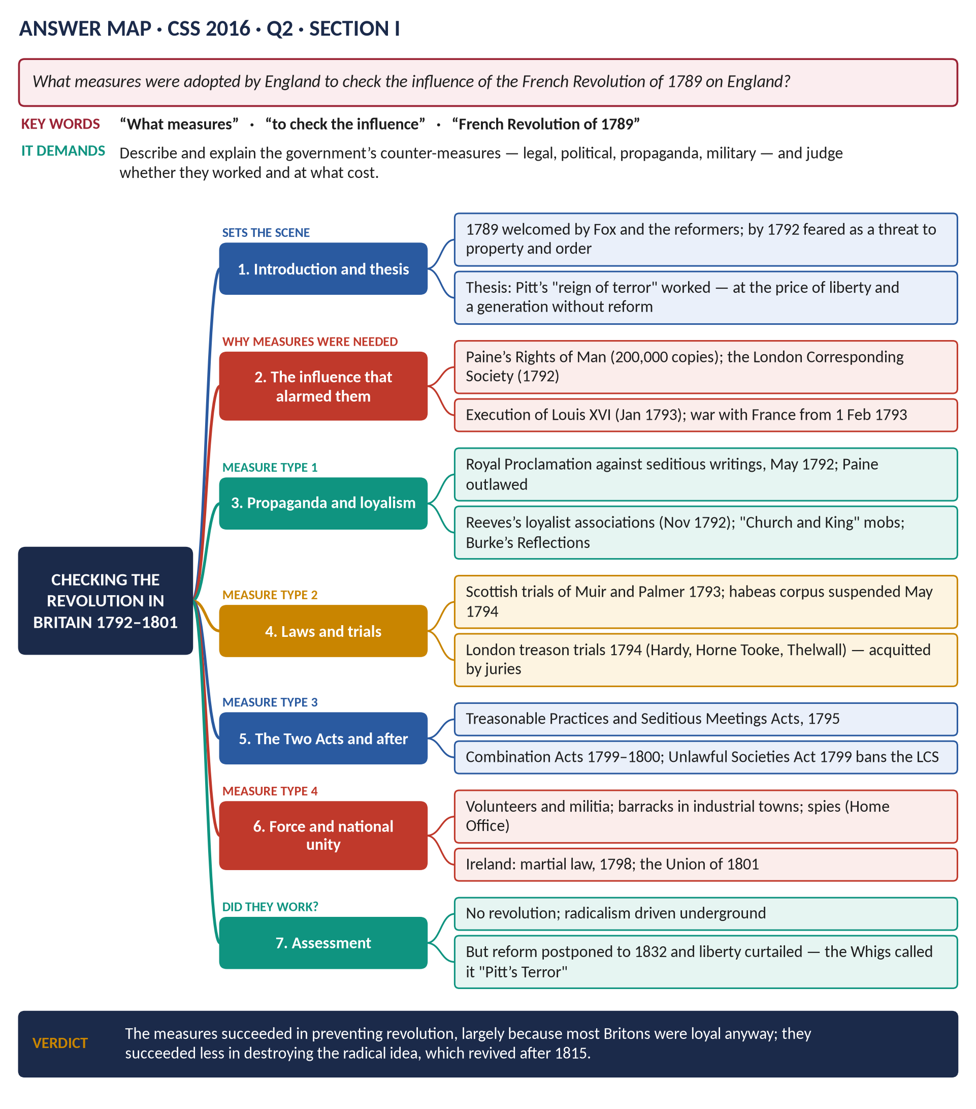
Figure 1 · The answer map for CSS 2016 · Q2 · Section A: every branch is one heading of the answer below.
DECODING THE QUESTION
"What measures" — the answer is built on the government's actions, grouped by type (propaganda, trials, laws, force, Ireland). "To check the influence" means you must first say briefly what influence was feared, and end by judging whether the measures worked.

The model answer

(1) Introduction and thesis
The French Revolution of 1789 was first welcomed in Britain, but by 1792 its spread of radical ideas — and from 1 February 1793 a war with France — convinced Pitt's government that Britain faced revolution at home. It answered with propaganda, prosecutions, emergency laws and force, a programme the Whigs called "Pitt's Terror". The measures succeeded in preventing revolution, but at the price of liberty and a generation's delay to reform.

(2) The influence that alarmed the government
- Ideas: Paine's Rights of Man (1791–92), which sold about 200,000 copies, attacked monarchy and aristocracy and demanded a republic.
- Organisation: the London Corresponding Society (January 1792), founded by the shoemaker Thomas Hardy, united artisans across the country behind manhood suffrage and annual parliaments.
- Events in France: the September Massacres (1792), the execution of Louis XVI (21 January 1793) and war.
- Ireland: the United Irishmen (1791) looked to France for a republic.

(3) Measure one: propaganda and loyalism
- The Royal Proclamation against seditious writings (May 1792); Paine was tried in his absence and outlawed.
- John Reeves's Association for Preserving Liberty and Property (November 1792) spread to hundreds of towns, reporting radicals and distributing loyalist tracts.
- Burke's Reflections (1790) supplied the intellectual case; "Church and King" crowds supplied the muscle — Priestley's house in Birmingham was burned in 1791.

(4) Measure two: prosecutions
- Scotland, 1793: Thomas Muir and Thomas Palmer were sentenced to transportation for sedition.
- London, 1794: Hardy, Horne Tooke and Thelwall were tried for high treason — and acquitted by juries, a sharp limit on the government's power.

(5) Measure three: emergency laws
Year | Law | What it did
1793 | Aliens Act | Registration and expulsion of foreigners
1794 | Habeas corpus suspended | Detention without trial (to 1801, with a gap)
1795 | Two Acts | Treasonable Practices (words could be treason); Seditious Meetings (no meeting of 50+ without a magistrate)
1797 | Newspaper Act | Registration of printers and presses
1799 | Unlawful Societies Act | Banned the LCS and the United Irishmen
1799–1800 | Combination Acts | Banned trade unions

(6) Measure four: force and war
- The militia and volunteer corps — over 400,000 men by 1804 — and new barracks in industrial towns.
- A network of Home Office spies and informers.
- Mutineers at the Nore (1797) executed.

(7) Measure five: Ireland
Martial law and brutal disarming (1797–98) crushed the 1798 rising; the Act of Union (in force 1 January 1801) abolished the Irish Parliament to close the "back door" to France.
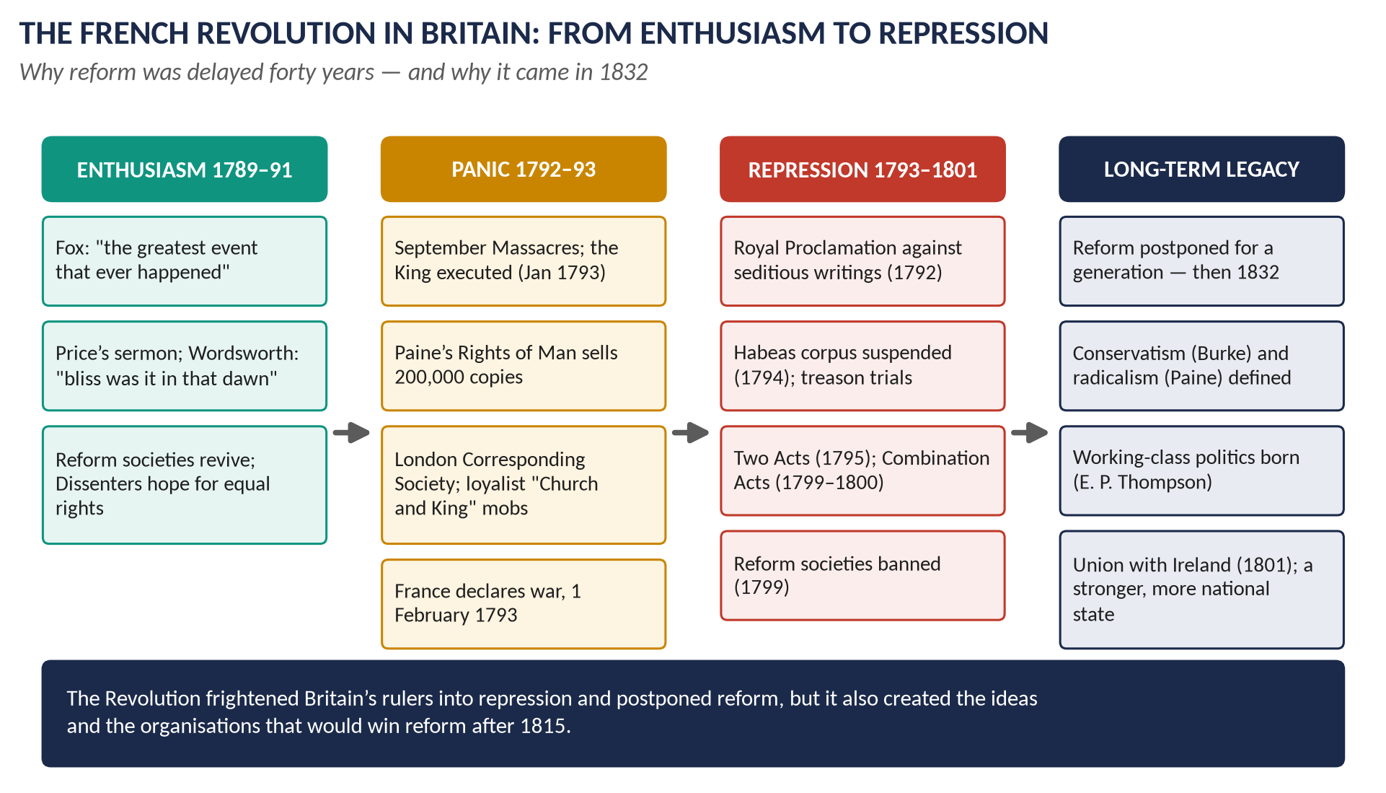
Figure 2 · From enthusiasm to repression: the British response to the Revolution.

(8) Did the measures work?
Yes | But
No revolution in Britain; radical societies broken by 1799 | Most Britons were loyal anyway (Dickinson) — the threat was exaggerated
Loyalism mobilised on a mass scale | Juries acquitted the treason defendants in 1794
Ireland secured for the war | Radicalism went underground and revived after 1815 (Peterloo, Chartism)
National unity for twenty-two years of war | Reform was postponed until 1832; trade unions illegal until 1824

(9) Conclusion
To check the influence of the French Revolution, Britain used propaganda, prosecutions, emergency laws, force and the Union with Ireland. They worked in the sense that mattered to Pitt — there was no British revolution — but they worked largely because most of the nation was loyal, and they did not kill the radical idea. They drove it underground, where it waited for the end of the war.
WHY THIS ANSWER SCORES
The measures are grouped by type rather than listed, the influence being checked is defined first, and the final table answers the implied question — did they work? — with evidence on both sides.

Answer 2 · The Influence of the French Revolution on English Society and Political Thought
THE QUESTION · CSS 2020 · Q3 · Section A · 20 marks
Estimate the influence of the French Revolution on English society and political thought.

Figure 3 · The answer map for CSS 2020 · Q3 · Section A: every branch is one heading of the answer below.
DECODING THE QUESTION
"Estimate" means measure the size of the influence, not just describe it. Two named areas: English society and political thought. Separate them, and distinguish short-term from long-term effects. This exact question was set again in 2022.

The model answer

(1) Introduction and thesis
The French Revolution of 1789, followed by twenty-two years of war with France (1793–1815), was the most important foreign influence on British life in the period. Its influence on political thought was decisive: the argument between Burke and Paine created modern British conservatism and radicalism. Its influence on society was strong but mixed — it produced a mass loyalism, a first working-class politics, repression and a stronger state — and it was matched by the other great force of the age, the Industrial Revolution.

Political thought

(2) Burke and conservatism
Edmund Burke's Reflections on the Revolution in France (1790) argued that society is "a partnership… between those who are living, those who are dead, and those who are to be born"; that rights come from inherited institutions, not abstract reason; and that revolution would end in terror and dictatorship — which it did. He also distinguished 1688, a conservative restoration, from 1789, a revolution. Burke gave the Tory party a philosophy it has used ever since.

(3) Paine and radicalism
Thomas Paine's Rights of Man (1791–92) replied that each generation may govern itself, that hereditary monarchy and aristocracy were absurd, and that a republic was best. Part 2 proposed old-age pensions, family allowances and public education paid for by progressive taxation. Selling perhaps 200,000 copies, it became the bible of British radicalism.

(4) The wider debate
- Mary Wollstonecraft, A Vindication of the Rights of Woman (1792): the first great British case for women's equality.
- William Godwin, Political Justice (1793): reason and the abolition of coercive government.
- Price and the Dissenters: the Revolution as the fulfilment of 1688.
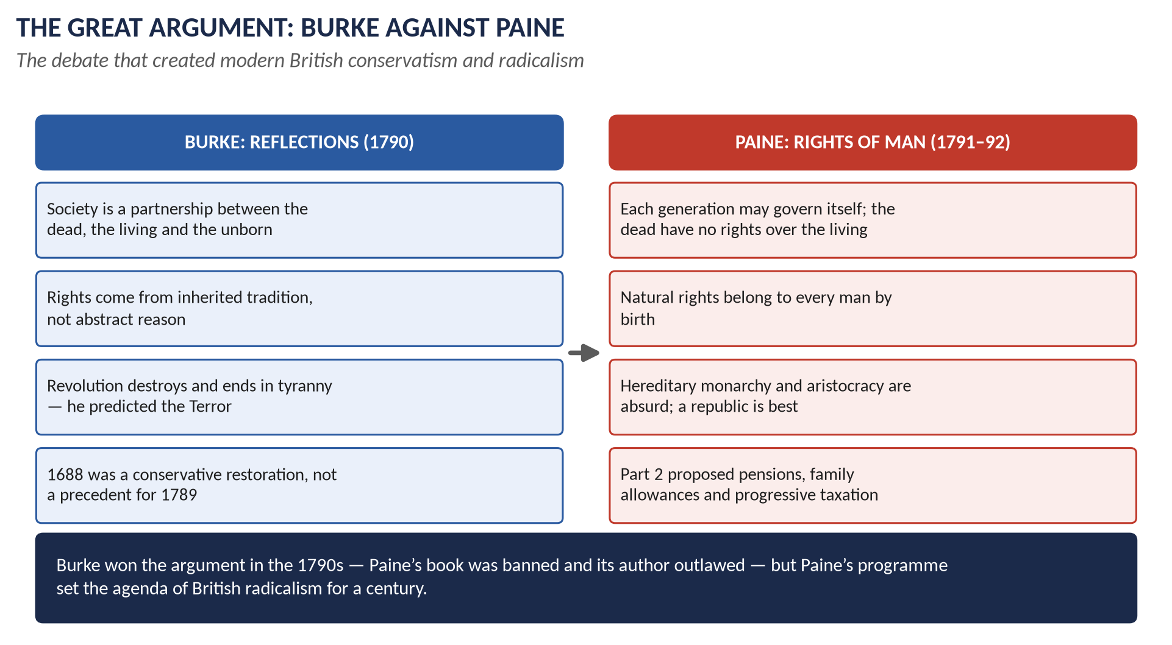
Figure 4 · Burke against Paine: the debate that defined British political thought.

(5) The effect on parties and reform
- The Whig party split in 1794: Portland's conservative Whigs joined Pitt, while Fox kept a small liberal opposition.
- Reform became identified with "Jacobinism": the moderate reform movement of the 1780s collapsed and parliamentary reform was postponed until 1832.

English society

(6) Popular politics and loyalism
- Radicalism: the London Corresponding Society (1792) and similar societies brought artisans into national politics. For E. P. Thompson, this was when the English working class began to "make itself".
- Loyalism: a larger mass movement — Reeves's associations, "Church and King" crowds, over 400,000 volunteers by 1804 (H. T. Dickinson).

(7) Repression and the state
Habeas corpus suspended (1794); the Two Acts (1795); the Combination Acts (1799–1800) banning trade unions until 1824. The state grew stronger: income tax (1799), a larger army and navy, a Home Office intelligence network.

(8) War, economy and identity
High taxes and food prices, food riots (1795, 1800), the naval mutinies (1797) and the Bank's suspension of cash payments (1797). The long war with a revolutionary, Catholic, republican enemy forged a stronger British identity (Linda Colley). Evangelical religion grew as the ruling class looked to morality as a defence against revolution.

(9) Ireland
The Revolution inspired the United Irishmen, the 1798 rising and the Act of Union (1801) — its most lasting constitutional effect on the British Isles.

(10) Estimate
Area | Short-term influence (1790s) | Long-term influence (after 1815)
Political thought | Very great: conservatism and radicalism defined | Very great: the language of rights, reform and democracy
Parties and reform | Great: Whig split, reform postponed | Great: Tory identity; the reform movement of 1815–32
Society | Great: loyalism, repression, war | Moderate: industrial change (T4) mattered as much

(11) Conclusion
The French Revolution's influence on English political thought was profound and permanent: Burke and Paine between them wrote the terms of British political argument for the next century. Its influence on society was great in the short term — mobilisation, repression, war — but in the long term it worked alongside, and was sometimes overshadowed by, the Industrial Revolution. Its democratic promise was delayed, not destroyed: it bore fruit in the reform movements after 1815.
WHY THIS ANSWER SCORES
"Estimate" is answered with an explicit scale (very great, great, moderate) in a table, and both named areas get their own sections. Named thinkers, laws and dates support every claim, and the answer places the Revolution beside the Industrial Revolution — the comparison that shows judgement.

Answer 3 · The Same Question, Set Again
THE QUESTION · CSS 2022 · Q5 · Section A · 20 marks
Estimate the influence of the French Revolution on English society and political thought.

DECODING THE QUESTION
2022 Q5 is word for word the same as 2020 Q3: "Estimate the influence of the French Revolution on English society and political thought." Answer 2 is the answer. The only question is how to present it freshly.

How to use Answer 2 in 2022 (or 2027)
1. Use the same structure — political thought, then society, then the estimate table. It is built on the question's own words.
2. Strengthen "estimate": open your conclusion with a single sentence of measurement — "The influence was greatest on political thought, considerable on politics and reform, and significant but shared with industrialisation on society."
3. Add one extra piece of evidence per section if you have time: the Priestley riots (1791); the 1794 treason acquittals; the Seditious Meetings Act limit of 50; the Nore mutiny.
4. Add Ireland as a separate short heading if the 2020 version did not have it — the Union of 1801 is the Revolution's most concrete constitutional legacy.
WHAT THE EXAMINER HAS ASKED · Why this matters
An identical question twice in three years is the clearest evidence in the whole record that this family is a favourite. Master Answer 2; it is one of the most likely questions in any future paper.

Answer 4 · "A Sort of Panic": The After-Effects of the French Revolution
THE QUESTION · CSS 2023 · Q3 · Section A · 20 marks
'The English people got so much frightened by the developments in France that there prevailed a sort of panic across the country.' Analyse the after-effects of the French Revolution on England.

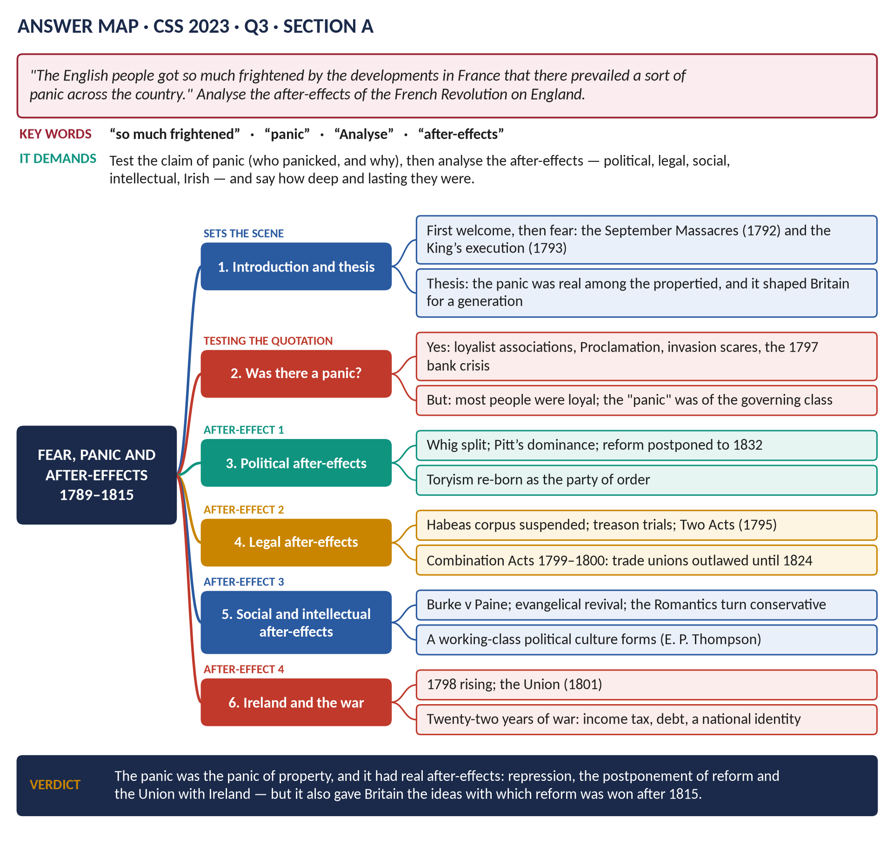
Figure 5 · The answer map for CSS 2023 · Q3 · Section A: every branch is one heading of the answer below.
DECODING THE QUESTION
Two tasks. First, test the quotation: was there a "panic"? Who panicked, and why? Second, analyse the after-effects on England — political, legal, social, intellectual, Irish — and judge how deep and lasting they were.

The model answer

(1) Introduction and thesis
The quotation is right that fear gripped England — but it was, above all, the fear of the propertied classes. From 1792 the violence in France, the spread of Paine's ideas and war with France produced a genuine panic among Britain's rulers, and that panic shaped the country for a generation: repression, a Tory ascendancy, the postponement of reform, and the Union with Ireland.

(2) From welcome to fear
In 1789 Fox, Price and Wordsworth welcomed the Revolution. By 1792 the mood had turned: the September Massacres, the abolition of the monarchy, the French offer of help to all peoples seeking liberty (the Edict of Fraternity, November 1792) and the opening of the Scheldt. The execution of Louis XVI (21 January 1793) and the declaration of war (1 February 1793) completed the transformation.

(3) Was there a panic?
Evidence of panic | Evidence against
Royal Proclamation (1792); Paine outlawed | Most people were loyal: loyalist associations far outnumbered radical societies
Loyalist associations in hundreds of towns | Juries acquitted the treason defendants (1794)
Habeas corpus suspended; treason trials | The LCS had perhaps 5,000 members at most
Invasion scares (1797–98, 1803–05); bank crisis (1797) | No serious revolutionary plot in England was ever proved

The panic, then, was real among the governing class and was fed by events; the country as a whole was more loyal than frightened.

The after-effects

(4) Political
- The Whig split (1794) left Pitt and his successors dominant; the Tories held power almost continuously until 1830.
- Reform became "Jacobinism" and was postponed until 1832.

(5) Legal
The Two Acts (1795), the Combination Acts (1799–1800) and the Unlawful Societies Act (1799) curtailed speech, assembly and trade unions; the machinery was revived after 1815 in the Six Acts (1819).

(6) Social and intellectual
- Burke v Paine: conservatism and radicalism defined.
- A first working-class political culture (E. P. Thompson), driven underground.
- Evangelical religion and moral reform as a defence against revolution; the Romantic poets turned conservative.

(7) Ireland
The Revolution inspired the United Irishmen and the 1798 rising (about 30,000 dead); Pitt's answer was the Act of Union (1801).

(8) War
Twenty-two years of war: income tax (1799), a debt of about £745 million, and a stronger British identity (Colley).
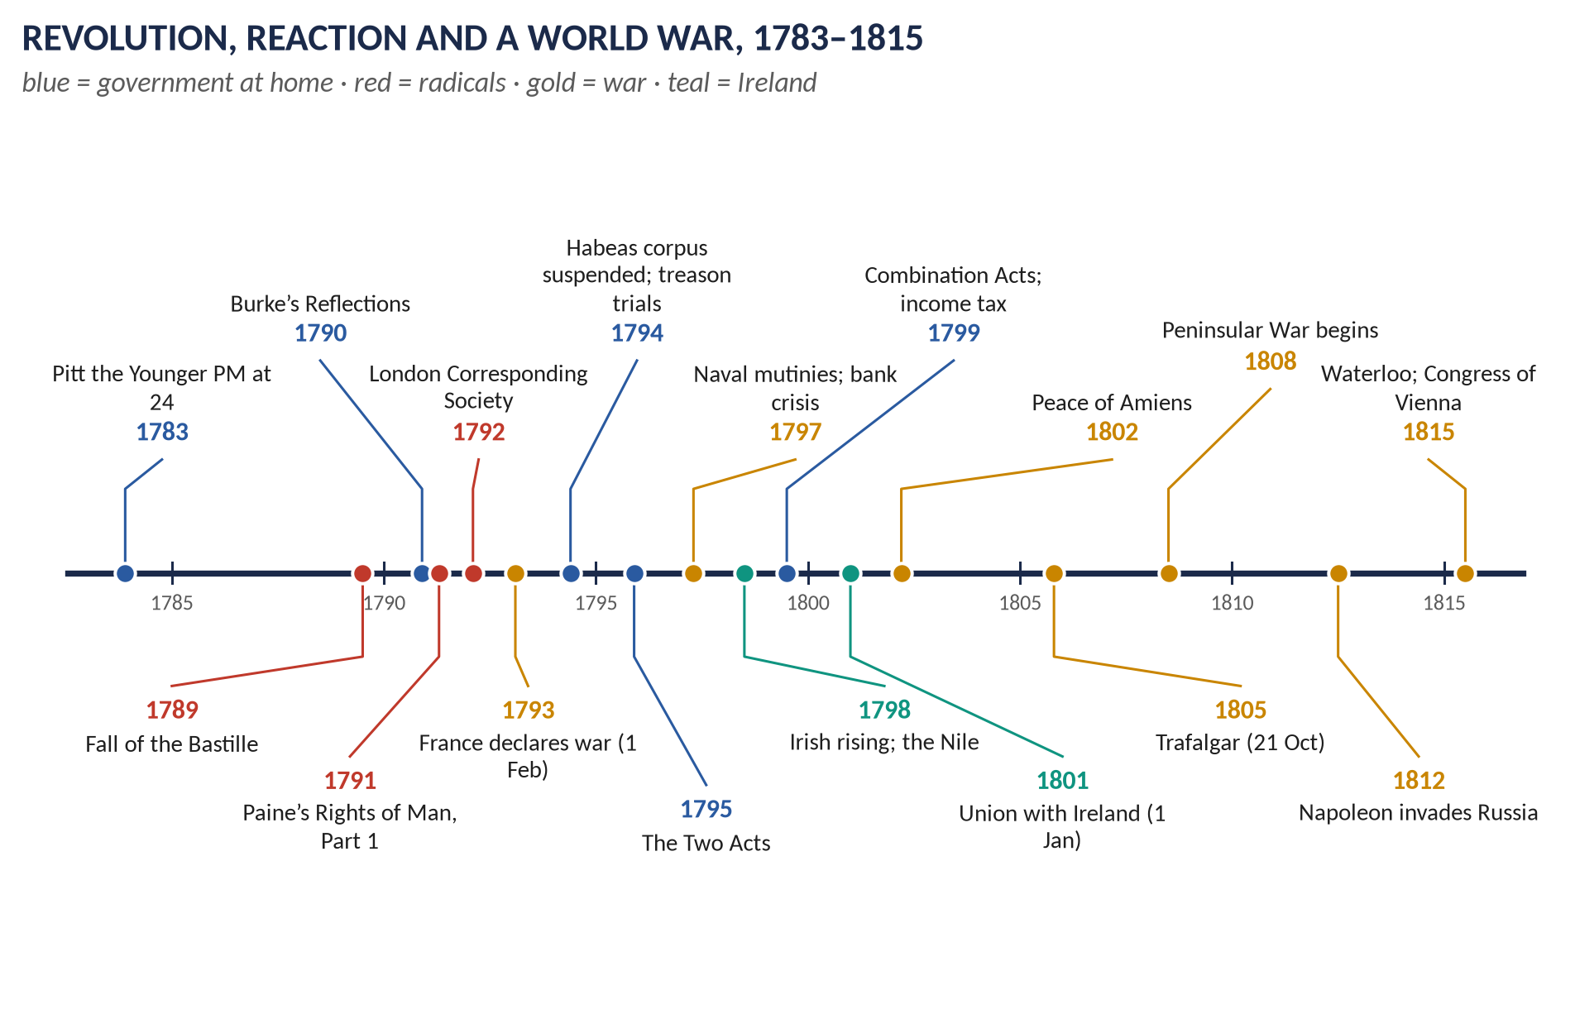
Figure 6 · From the Bastille to Waterloo: the sequence of fear, repression and war.

(9) Conclusion
The quotation captures the mood of Britain's rulers in the 1790s: they were frightened, and they acted on their fear. The after-effects were repression, Tory dominance, the postponement of reform, the Union with Ireland and a long, costly war — but also the birth of modern conservatism and radicalism. The panic delayed reform by a generation; it did not prevent it.
WHY THIS ANSWER SCORES
The quotation is tested with evidence on both sides before the after-effects are analysed, and the after-effects are grouped by type. Distinguishing the panic of the propertied from the loyalty of the majority is the judgement the question rewards.

Short Note

Impact of the French Revolution on the British Economy and Society
THE QUESTION · CSS 2025 · Q8(a) · Section B · short note (10 marks)
Write a short note on: Impact of the French Revolution on the British economy and society

DECODING THE QUESTION
A 10-mark short note (450–600 words). Keep it to economy and society; political thought appears only as it affected society.

(1) Introduction
The French Revolution (1789) and the wars it produced (1793–1815) reshaped the British economy and society as much through war as through ideas.

(2) The economy
- Taxation: income tax introduced by Pitt in 1799 (2s in the pound on incomes over £200); indirect taxes on almost everything.
- Debt: the National Debt rose from about £240 million to about £745 million.
- Money: the Bank of England suspended cash payments (1797–1821).
- Trade: the Continental System (1806) and the Orders in Council (1807) disrupted exports; new markets were found in South America and the empire.
- Industry and agriculture: war demand stimulated iron and cotton; high wheat prices encouraged enclosure; the Corn Law of 1815 protected farmers after the war.

(3) Society
- Politics of the people: the London Corresponding Society (1792) and the first working-class political organisations (E. P. Thompson).
- Loyalism: Reeves's associations; "Church and King" crowds; 400,000 volunteers by 1804.
- Repression: habeas corpus suspended (1794); the Two Acts (1795); the Combination Acts (1799–1800) outlawing trade unions.
- Hardship: food riots (1795, 1800); the naval mutinies (1797); after 1815, unemployment among some 300,000 demobilised men, Luddism and Peterloo (1819).
- Identity and religion: a stronger British patriotism (Colley); evangelical revival.

(4) Assessment
The Revolution's economic impact came mainly through war finance — income tax and debt — and its social impact through mobilisation and repression. Together they left post-war Britain heavily taxed, socially divided and politically restless: the setting for the Age of Reform.

Answer 5 · The Act of Union 1801: Controversies, Nationalism and Stability
THE QUESTION · CSS 2025 · Q3 · Section A · 20 marks
Analyze the controversies surrounding the Act of Union 1801, focusing on the differing perspectives of Irish and British politicians. Assess its impact on Irish nationalism and the stability of the United Kingdom.

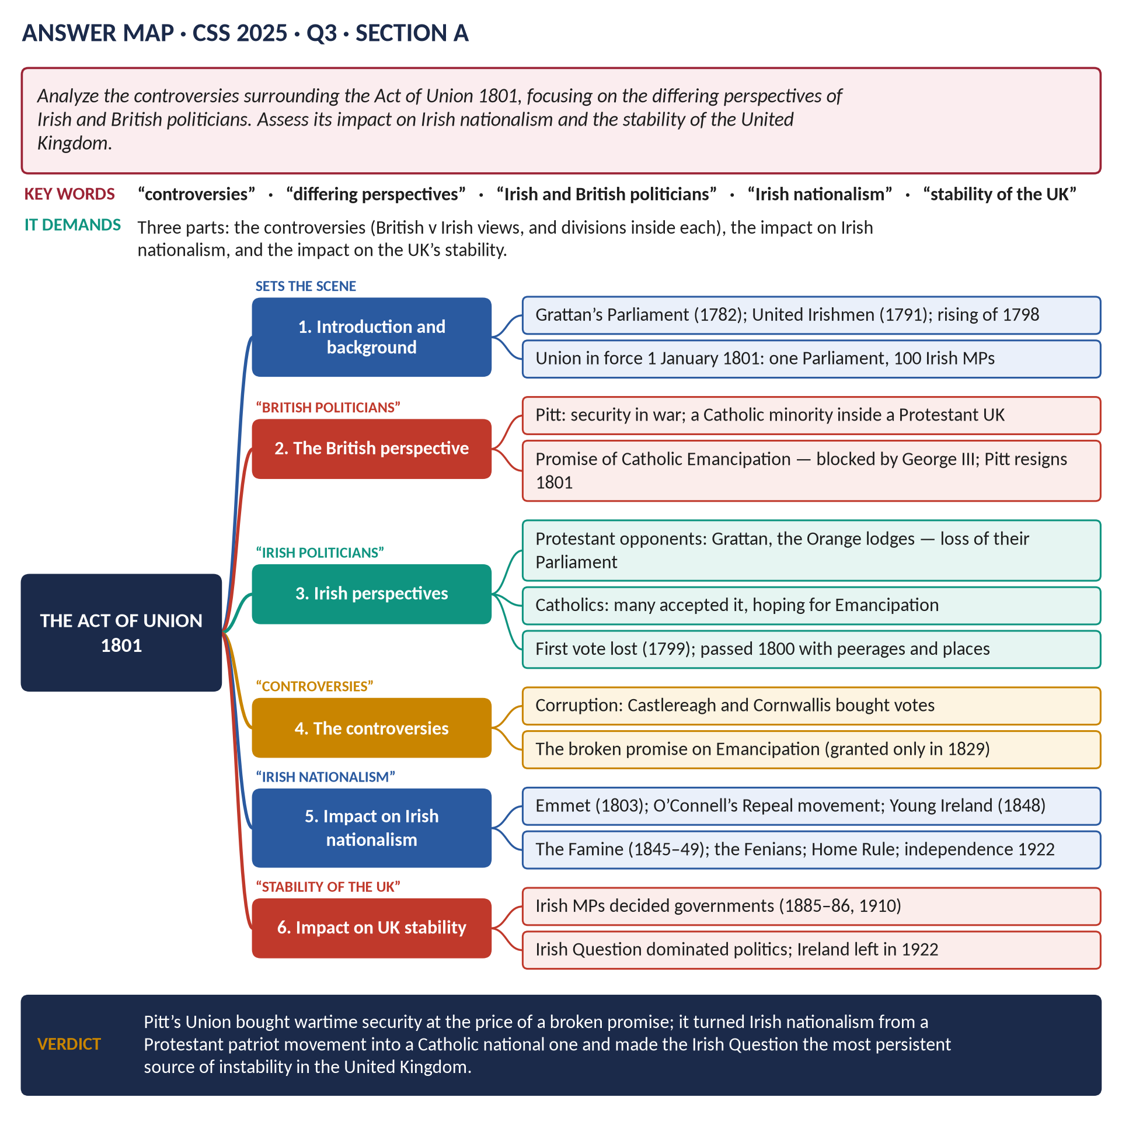
Figure 7 · The answer map for CSS 2025 · Q3 · Section A: every branch is one heading of the answer below.
DECODING THE QUESTION
Three tasks: (1) the controversies, organised around the differing perspectives of Irish and British politicians — and remember that Irish politicians were themselves divided (Protestant and Catholic); (2) the impact on Irish nationalism; (3) the impact on the stability of the United Kingdom.

The model answer

(1) Introduction and thesis
The Act of Union, in force from 1 January 1801, abolished the Irish Parliament and created the United Kingdom of Great Britain and Ireland. It was Pitt's answer to the 1798 rising and to the danger of a French "back door" in wartime. It was controversial from the start — bought with patronage, opposed by Protestant patriots, accepted by Catholics on a promise that was broken — and its long-term effect was to turn Irish nationalism into a Catholic national movement and to make the Irish Question the most persistent source of instability in British politics.

(2) Background
- The Protestant Ascendancy governed a Catholic majority under the Penal Laws.
- Grattan's Parliament (1782) won legislative independence but remained Protestant.
- The United Irishmen (1791), under Wolfe Tone, moved from reform to republicanism; the 1798 rising, helped by a French landing at Killala, cost about 30,000 lives.
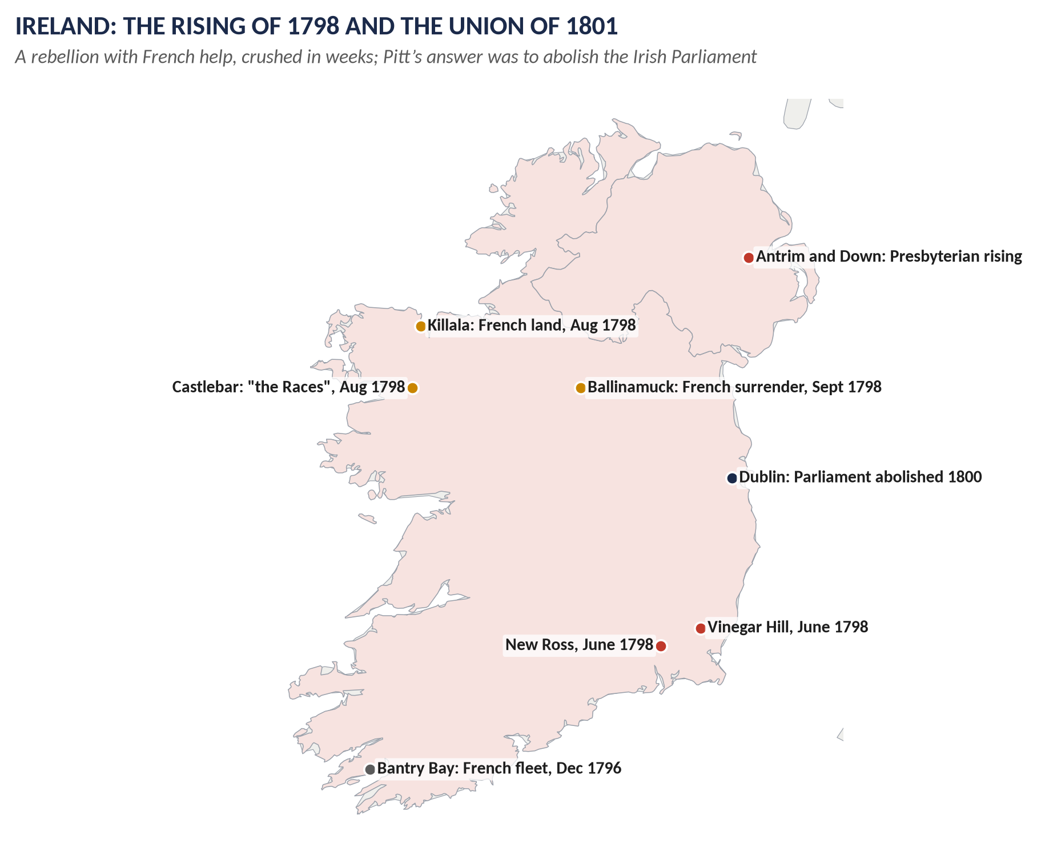
Figure 8 · 1798: the rising and the French landing that convinced Pitt to abolish the Irish Parliament.

(3) The British perspective
- Security: Ireland was a gateway for French invasion; a single Parliament would control it.
- Control: an independent Dublin Parliament could defy London (as over the Regency in 1788–89).
- Religion: inside a Protestant United Kingdom, Catholics would be a minority and could safely be emancipated.
- Economy: free trade would bring prosperity to Ireland.

(4) The Irish perspectives
Group | Perspective
Protestant patriots (Grattan, Foster) | Union destroyed "their" Parliament and Ireland's nationhood; they fought it bitterly
The Orange Order | Divided: many feared Union would bring Catholic Emancipation
Catholic leaders and bishops | Many supported or accepted it, expecting Emancipation from a Westminster Parliament
The borough-owners | Could be bought — and were

(5) The controversies
1. Corruption: the Irish Commons rejected Union in 1799; in 1800 it passed after Castlereagh and Cornwallis distributed peerages, places and about £1.25 million in compensation to the owners of abolished boroughs.
2. The broken promise: Pitt had implied that Catholic Emancipation would follow. George III refused, citing his coronation oath; Pitt resigned (February 1801). Emancipation came only in 1829, extracted by O'Connell's mass movement.
3. Representation: Ireland, with about a third of the UK's population, received only 100 of 658 seats.

(6) The impact on Irish nationalism
- From Protestant to Catholic nationalism: the patriot tradition of Grattan gave way to a Catholic movement — O'Connell's Catholic Association and Repeal campaign (1840s).
- Revolutionary republicanism: Emmet (1803), Young Ireland (1848), the Fenians (from 1858), the Easter Rising (1916).
- The Famine (1845–49) under the Union — about a million dead and a million emigrants — became the central grievance.
- Constitutional nationalism: Home Rule (Butt, Parnell, Redmond) from the 1870s.

(7) The impact on the stability of the United Kingdom
- The Irish Question split Peel's party (Corn Laws in the Famine, 1846) and Gladstone's (Home Rule, 1886).
- Irish MPs held the balance of power in 1885–86 and 1910, forcing Home Rule onto the agenda.
- Ulster Unionism and the crisis of 1912–14 brought Britain close to civil war.
- The Union ended for most of Ireland in 1922 (Irish Free State); Northern Ireland's troubles (1968–98) were its last legacy.

(8) Conclusion
The Act of Union was a wartime security measure carried by corruption and sold to Catholics on a promise the King would not keep. British politicians saw it as the solution to the Irish problem; Protestant patriots saw it as the death of their nation; Catholics saw it as a bargain that was broken. By turning Irish nationalism into a Catholic, national and eventually republican movement, the Union created the Irish Question that destabilised British politics for more than a century and ended, for most of Ireland, in independence in 1922.
WHY THIS ANSWER SCORES
The two named perspectives are set out separately — and the Irish side is shown to be divided, which most candidates miss. Nationalism and stability each get their own section, carried forward to 1922 so the "impact" is complete.

Part Two — The Past MCQs, Solved

CSS 2024 · MCQ 15
The Battle of Waterloo was fought on:
(A) 18 June 1815 | (B) 18 June 1915 | (C) 18 June 1917 | (D) None of these

REMEMBER · Answer: A. 18 June 1815
Waterloo was fought on 18 June 1815; Wellington and Blücher defeated Napoleon's final campaign, the Hundred Days.

CSS 2026 · MCQ 5
The Act of Union 1801 created the United Kingdom of:
(A) Great Britain and Scotland | (B) England and Scotland | (C) Great Britain and Ireland | (D) None of these

REMEMBER · Answer: C. Great Britain and Ireland
The Act of Union 1801 joined Great Britain (England, Wales and Scotland, united in 1707) with Ireland, creating the United Kingdom of Great Britain and Ireland.

CSS 2026 · MCQ 15
The French Revolution led to Britain:
(A) Supporting the French monarchy | (B) Declaring war on France | (C) Remaining neutral | (D) None of these

REMEMBER · Answer: D. None of these — revolutionary France declared war on Great Britain on 1 February 1793
Britain did not declare war, support the French monarchy, or stay neutral: revolutionary France declared war on Britain on 1 February 1793. None of the options fits, so the key is "None of these".

Part Three — Five Predicted Questions, with Outlines
NOTE · Why these five
They come from the topic's blind spots: the Napoleonic Wars themselves, Pitt the Younger, Burke and Paine as a question on their own, and the Irish rising.

Predicted 1 · "How did Britain contribute to the defeat of Napoleon?"
- Thesis: sea power made Britain invulnerable and money kept the coalitions alive; the Peninsula and Waterloo were Britain's direct contribution on land.
- Headings: (1) Why Britain fought · (2) Sea power: the Nile, Trafalgar, blockade · (3) Money: income tax, credit, subsidies to seven coalitions · (4) Economic war: Continental System v Orders in Council · (5) The Peninsular War · (6) Waterloo and Vienna · (7) Verdict: decisive, but alongside Russia, Austria and Prussia.

Predicted 2 · "Assess the impact of the Napoleonic Wars on Britain."
- Headings: (1) Finance: £1,000 million, income tax, debt · (2) Economy: industry, agriculture, the Corn Law (1815) · (3) Society: repression, identity, post-war distress · (4) Politics: Tory dominance; Peterloo and the Six Acts · (5) World role: Vienna, bases, naval supremacy · (6) Verdict.

Predicted 3 · "Evaluate Pitt the Younger as a peacetime reformer and a war minister."
- Thesis: a first-rate reformer of finance before 1793, a determined but uninspired war leader after it.
- Headings: (1) Rise to power (1783–84) · (2) Finance and trade · (3) India, Canada, the slave trade · (4) The failure of reform · (5) War strategy · (6) Repression · (7) The Union and resignation · (8) Verdict.

Predicted 4 · "Compare the political ideas of Edmund Burke and Thomas Paine."
- Headings: (1) Context: Price's sermon and the debate · (2) Society and tradition v natural rights · (3) 1688 v 1789 · (4) Monarchy and aristocracy · (5) Change: gradual reform v revolution · (6) Influence: conservatism and radicalism · (7) Verdict.

Predicted 5 · "What were the causes and consequences of the Irish rebellion of 1798?"
- Headings: (1) The Protestant Ascendancy and the Penal Laws · (2) Grattan's Parliament · (3) The United Irishmen and France · (4) The rising and the French landing · (5) Consequences: repression, the Union, the Emancipation question · (6) Verdict.

